# SRM UNIVERSITY ANDHRA PRADESH



Object Oriented Programming Project on

**“SRM Hostel management System”**

for the partial fulfilment of the requirements to award the degree of

**Bachelor of Technology In**

**Computer Science and Engineering**

Submitted by –

|  |  |  |
| --- | --- | --- |
| **Name** | **Branch and**  **Year** | **Registration**  **Number** |
| SRI HARSHA | CSE-E, 2nd Year | AP21110010007 |
| B.V.N. HAREESH | CSE-E, 2nd Year | AP21110010839 |
| NIMSHARI.R | CSE-E, 2nd Year | AP21110010009 |
| DHRUV SHARMA | CSE-E, 2nd Year | AP21110010043 |
| REETHU BHARGAVI.S | CSE-E, 2nd Year | AP21110010045 |

Under the Guidance of

**Dr. Neeraj Kumar Sharma**

# ABSTRACT

* This project "Hostel Management System" target for all the hostel in the school

and college and other this transition of hostel management system from the better

control and timely response.

* This eliminates the time delay and paperwork, the warden is provided with the

control on the system to add or deleting the details of the student and edit and see the

details of the student details.

* Even the higher authorities of the school and college can easily access to

see the data.

# INTRODUCTION

* It is not recommended to use a manual system currently, when automated

systems can be software or hardware.

* Hostels that do not have a management system typically do everything by hand.
* The verification of registration forms to other processes for saving data is done by

hand, and most of the time, it is written on paper.

* As a result, an automated system can avoid a lot of repetitions.
* A computerized system that will help reduce the number of manuals

inputs are being designed in response to the shortcomings of the current systems.

* We can overcome the shortcomings of the current manual system by increasing its

efficiency with this system in place.

* The management of the hostel can save student records about their rooms and other

things thanks to the system's design.

* It relieves them of manual labor, which makes it difficult to locate student records.
* The room allocation is better managed thanks to this system, which provides information about students as well as fee details.
* Special features like the number of students in a room, student ID, and free rooms or

space will be included in the hostel management system.

* Each member of the administration and each student's information has a distinct identity in the administration.

# OBJECTIVE

The project’s main idea is to provide basic amenities that would suffice and quickly enhance the user’s experience and requirements, which would help in maintaining transparency between members

**Algorithm:**

**STEP1: -**The code is a simple program that creates 10 nodes, each with an integer value

and name.

**STEP2: -**The code then prints the names of all the nodes in order from 0 to 9.

**STEP3: -**The first line of the function create () declares a for loop that iterates through 10 times.

Each iteration has two statements: one is creating a new node and assigning it to

header[i], which will

Be printed on-screen; the other statement assigns cn->next = NULL, which means that

this node will

not have any children (children are nodes with parents).

**STEP4: -** If there is no child before this node, then header[i] becomes nn->num = 1; otherwise,

cn->next points to another parent node until it reaches NULL.

**STEP5: -**The code creates a new instance of the class "node" which is initialized with the value of 0.

**STEP6: -**The code then creates ten instances of "node" and initializes them with values

1, 0, and NULL respectively.

**STEP7: -**This will create ten nodes in total, one for each row in the matrix-like structure created by

these lines of code.

**STEP8: -**The variable is initialized to the header array, which contains all of the floor numbers in order

from 0-9.

**STEP9: -**The code then declares another variable called nn and initializes it to point to

the first element

in the list (the one with index 0).

**STEP10: -**If so, then nn points back at itself and its previous value becomes cn again as shown below:

if (j == 5 || j == 6 || j == 7) { cn->num = 2; } If not for any of these conditions being true

then nnn points

at itself and its previous value becomes null because nothing else has been assigned yet

as shown below:

**STEP11: -** if

The code is used to generate a list of all the numbers in the range 1-100.

The code starts with a for loop that iterates through 100 times, which will display all the numbers from

1-100 on one line.

**STEP12: -**

The code then creates an array called header and initializes it with a 0.

It then uses this array to store the current number being displayed.

**STEP13: -**

The next part of the code is where it generates a list of every single possible number

from 1-100 by

using nested if statements, which are explained below:

**STEP14: -** if (j

The code starts by printing the number of vacant cots in each room.

Then it prints a message for every room that is not empty.

The code starts with an if statement that checks whether there are any vacancies

in the first three

rooms and then proceeds to check all other rooms.

**STEP15: -**

If there are no vacancies, it prints "Present" followed by a space and then moves on

to the next line

of code.Otherwise, it prints "Vacant cots->" followed by the number of vacant cots in

that particular

room followed by a space and then moves on to the next line of code.

**STEP16: -**

This code also declares two more arrays: one for login and another for logout.

Next, there are three if statements inside mainmenu().

**STEP17: -**

If strcmp(name,l) does not equal 0 then it means that you have entered your own

username into

this program and you need to register with your username before continuing with any

other actions

in this program.

**STEP18: -**

If strcmp(name,l) equals 0 then it means that you are trying to log into someone else's account so they

can re-log out or change their password; therefore, they must exist as well as being logged into at least

once before proceeding further with anything else in mainmenu().

**STEP19: -** Finally if strcmp(name,"") equals 0 then it means that no one exists on this computer, and you need to create them by pressing enter when prompted during

**Block Diagram**

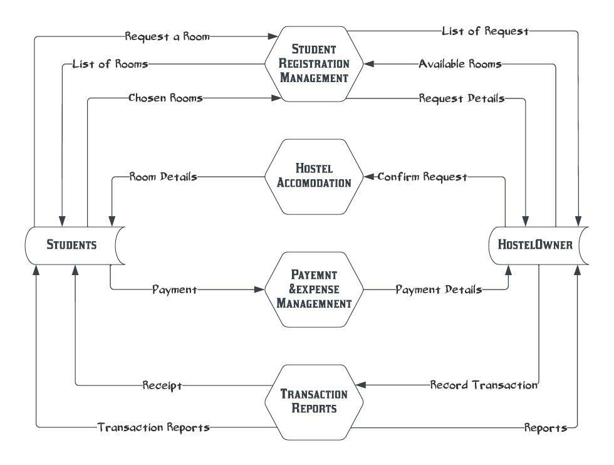

**UML Diagram –**

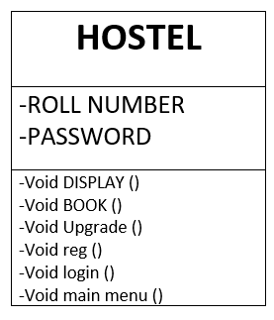

# SYSTEM IMPLEMENTATION

**Modules or Functions**

* Main Function of the program

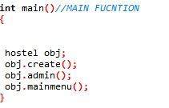

We have created a structure for storing the data of student and we have created a class hostel, containing functions like:

* Void reg ()
* Void admin ()
* Void upgrade ()
* Void book ()
* Void login ()
* Void main menu ()

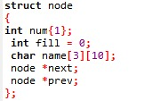

* In this registration function the use will register.

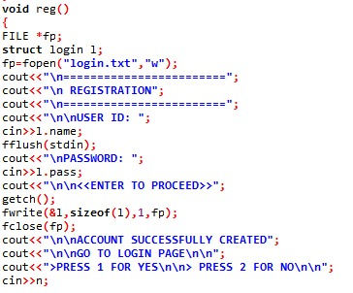

* In this function we display the main menu.

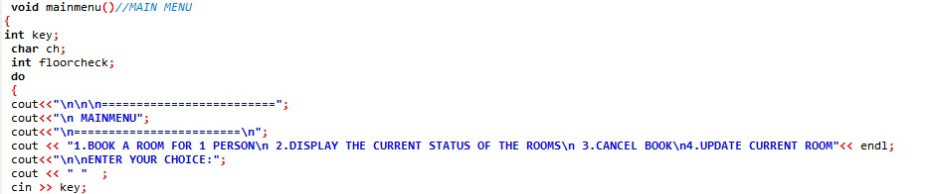

* In this function the person will be login with the help of this function.

* In this function we can upgrade the data.

* In this function we book the room for the user.

# RESULTS

**Sample input and output**

* Display Main Menu and book a room.

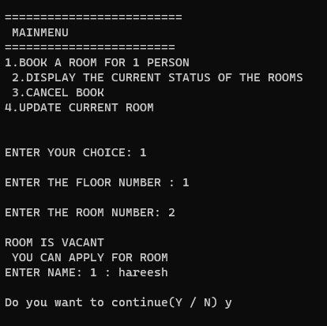

* Display The currency status of the rooms

* Cancel book

* Update current room

**System Requirement Specification**

